Priority scheduling non-pre-emptive

#include <stdio.h>

int main()
{
int n;
int pid[20], at[20], bt[20], pr[20];
int ct[20], tat[20], wt[20];
int completed[20] = {0};

int current_time = 0, completed_count = 0;
int i;

printf("Enter number of processes: ");
scanf("%d", &n);

for(i = 0; i < n; i++)
{
printf("\nProcess %d\n", i+1);
printf("Enter Process ID: ");
scanf("%d", &pid[i]);

printf("Enter Arrival Time: ");
scanf("%d", &at[i]);

printf("Enter Burst Time: ");
scanf("%d", &bt[i]);

printf("Enter Priority: ");
scanf("%d", &pr[i]);
}

while(completed_count < n)
{
int highest_priority = 9999;
int selected_process = -1;

for(i = 0; i < n; i++)
{
if(at[i] <= current_time && completed[i] == 0)
{
if(pr[i] < highest_priority)
{
highest_priority = pr[i];
selected_process = i;
}
}
}

if(selected_process == -1)
{
current_time++;
}
else
{
ct[selected_process] = current_time + bt[selected_process];
tat[selected_process] = ct[selected_process] - at[selected_process];
wt[selected_process] = tat[selected_process] - bt[selected_process];

current_time = ct[selected_process];
completed[selected_process] = 1;
completed_count++;
}
}

printf("\nProcess\tAT\tBT\tPriority\tCT\tTAT\tWT\n");

for(i = 0; i < n; i++)
{
printf("P%d\t%d\t%d\t%d\t\t%d\t%d\t%d\n",
pid[i], at[i], bt[i], pr[i], ct[i], tat[i], wt[i]);
}

return 0;
}
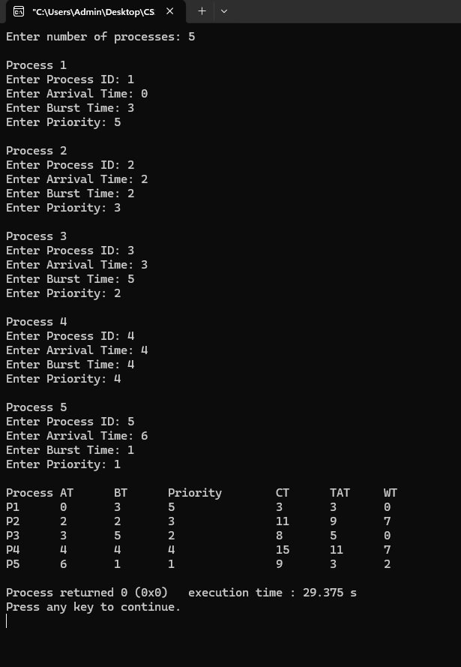

Priority scheduling Pre-emptive

#include <stdio.h>

int main()
{
int n, choice;
int pid[20], pr[20], at[20], bt[20], rt[20];
int ct[20], tat[20], wt[20];
int completed = 0, current_time = 0;
int i, selected, best_priority;

float avg_wt = 0, avg_tat = 0;

printf("Enter number of processes: ");
scanf("%d", &n);

printf("Enter priorities (1 for higher number means higher priority, 2 for lower number means higher priority): ");
scanf("%d", &choice);

printf("Enter priorities:\n");
for(i=0;i<n;i++)
scanf("%d",&pr[i]);

printf("Enter arrival times:\n");
for(i=0;i<n;i++)
scanf("%d",&at[i]);

printf("Enter burst times:\n");
for(i=0;i<n;i++)
{
scanf("%d",&bt[i]);
rt[i] = bt[i];
pid[i] = i+1;
}

while(completed < n)
{
selected = -1;

if(choice == 2)
best_priority = 9999;
else
best_priority = -1;

for(i=0;i<n;i++)
{
if(at[i] <= current_time && rt[i] > 0)
{
if(choice == 2)
{
if(pr[i] < best_priority)
{
best_priority = pr[i];
selected = i;
}
}
else
{
if(pr[i] > best_priority)
{
best_priority = pr[i];
selected = i;
}
}
}
}

if(selected == -1)
{
current_time++;
}
else
{
rt[selected]--;
current_time++;

if(rt[selected] == 0)
{
ct[selected] = current_time;
tat[selected] = ct[selected] - at[selected];
wt[selected] = tat[selected] - bt[selected];

avg_tat += tat[selected];
avg_wt += wt[selected];

completed++;
}
}
}

printf("\nPriority Scheduling (Pre-Emptive):\n");
printf("PID\tPrior\tAT\tBT\tCT\tTAT\tWT\tRT\n");

for(i=0;i<n;i++)
{
printf("P%d\t%d\t%d\t%d\t%d\t%d\t%d\t%d\n",
pid[i], pr[i], at[i], bt[i], ct[i], tat[i], wt[i], wt[i]);
}

printf("\nAverage turnaround time: %.6f\n", avg_tat/n);
printf("Average waiting time: %.6f\n", avg_wt/n);

return 0;
}

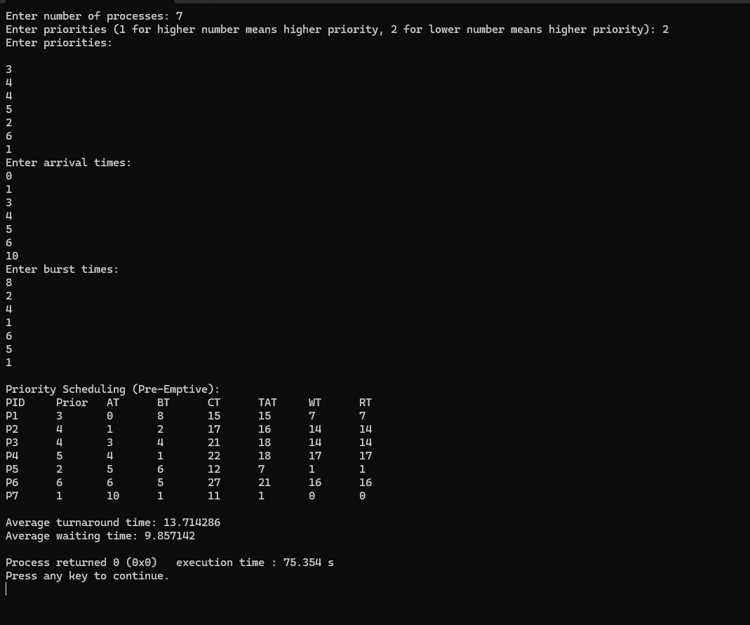

Round Robin

#include <stdio.h>

int main()
{
int n, tq;
int at[20], bt[20], rt[20];
int ct[20], tat[20], wt[20];
int i, time = 0, remain, flag = 0;

float avg_wt = 0, avg_tat = 0;

printf("Enter number of processes: ");
scanf("%d",&n);

printf("Enter Time Quantum: ");
scanf("%d",&tq);

printf("Enter arrival times:\n");
for(i=0;i<n;i++)
scanf("%d",&at[i]);

printf("Enter burst times:\n");
for(i=0;i<n;i++)
{
scanf("%d",&bt[i]);
rt[i] = bt[i];
}

remain = n;

for(time=0,i=0; remain!=0;)
{
if(rt[i] <= tq && rt[i] > 0)
{
time += rt[i];
rt[i] = 0;
flag = 1;
}
else if(rt[i] > 0)
{
rt[i] -= tq;
time += tq;
}

if(rt[i]==0 && flag==1)
{
remain--;
ct[i] = time;
tat[i] = time - at[i];
wt[i] = tat[i] - bt[i];

avg_wt += wt[i];
avg_tat += tat[i];

flag = 0;
}

if(i == n-1)
i = 0;
else if(at[i+1] <= time)
i++;
else
i = 0;
}

printf("\nRRS scheduling:\n");
printf("PID\tAT\tBT\tCT\tTAT\tWT\tRT\n");

for(i=0;i<n;i++)
{
printf("%d\t%d\t%d\t%d\t%d\t%d\t%d\n",
i+1, at[i], bt[i], ct[i], tat[i], wt[i], rt[i]);
}

printf("\nAverage turnaround time: %.6fms\n", avg_tat/n);
printf("\nAverage waiting time: %.6fms\n", avg_wt/n);

return 0;
}

